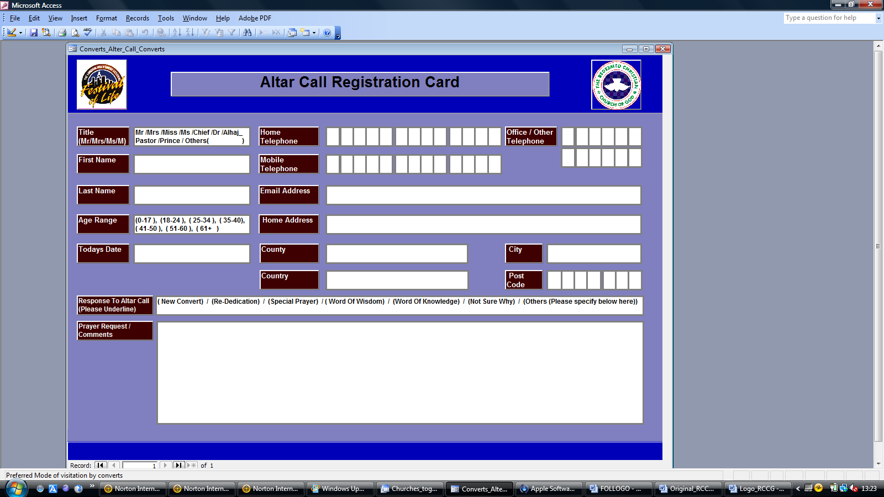

RE-DEDICATION

NEW CONVERT

**P.T.O.**

……………………………………………………………………………………………………………………………………………………………

……………………………………………………………………………………………………………………………………………………………

……………………………………………………………………………………………………………………………………………………………

……………………………………………………………………………………………………………………………………………………………

……………………………………………………………………………………………………………………………………………………………

……………………………………………………………………………………………………………………………………………………………

……………………………………………………………………………………………………………………………………………………………

……………………………………………………………………………………………………………………………………………………………

……………………………………………………………………………………………………………………………………………………………

……………………………………………………………………………………………………………………………………………………………

……………………………………………………………………………………………………………………………………………………………

……………………………………………………………………………………………………………………………………………………………

……………………………………………………………………………………………………………………………………………………………

……………………………………………………………………………………………………………………………………………………………

……………………………………………………………………………………………………………………………………………………………

…………………………………………………………………………………………………………………………………………………………….

……………………………………………………………………………………………………………………………………………………………

…………………………………………………………………………………………………………………………………………………………….

**Prayer Points Cont..**